# Simple, Storage, Service (S3)

Click on S3

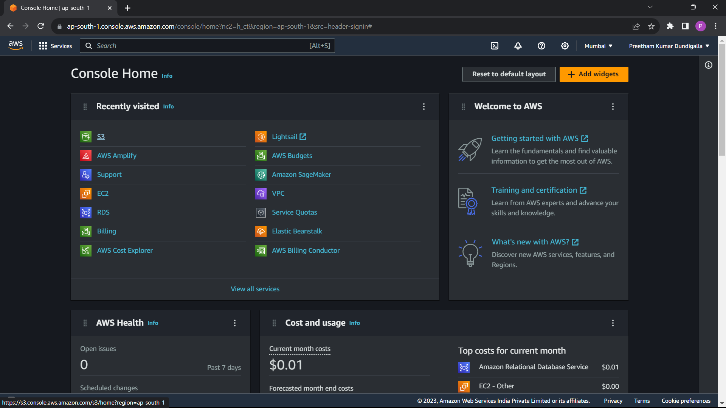

Create bucet

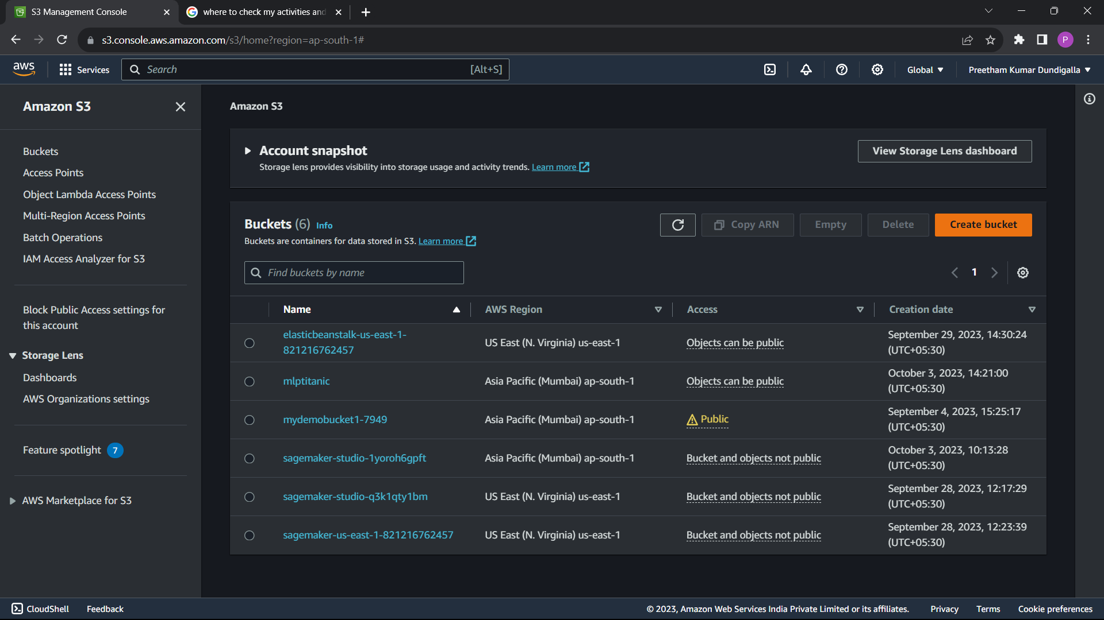

Provide all necessary configurations.

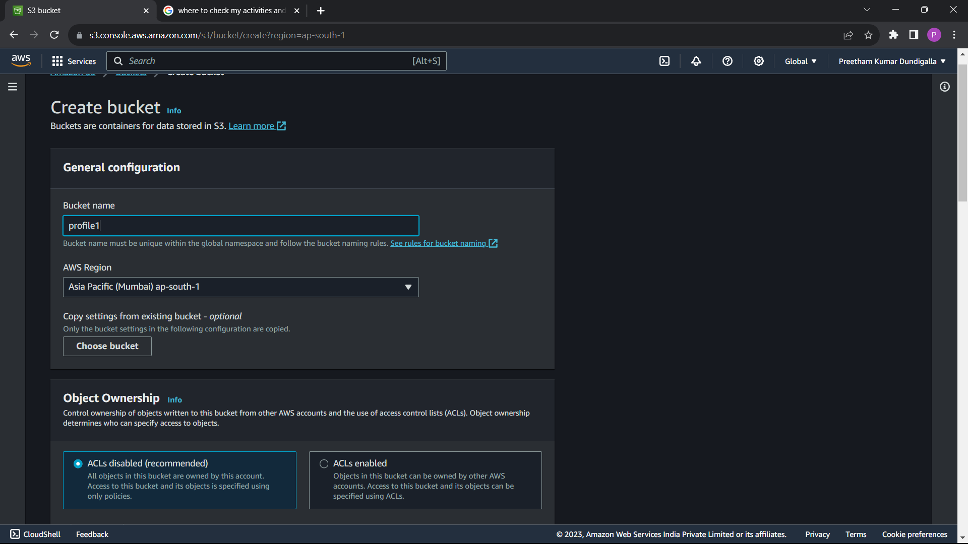

Create a folder in it.

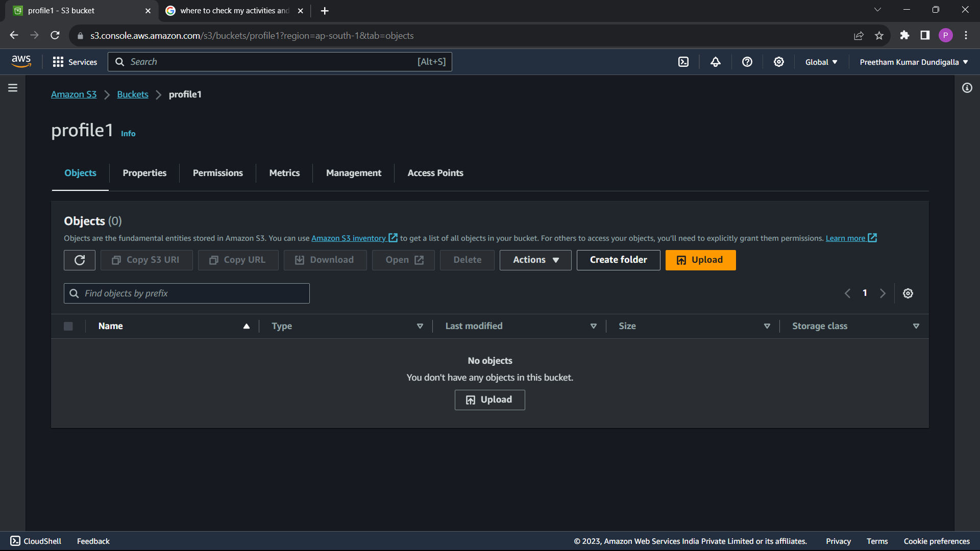

Give folder name and then create folder

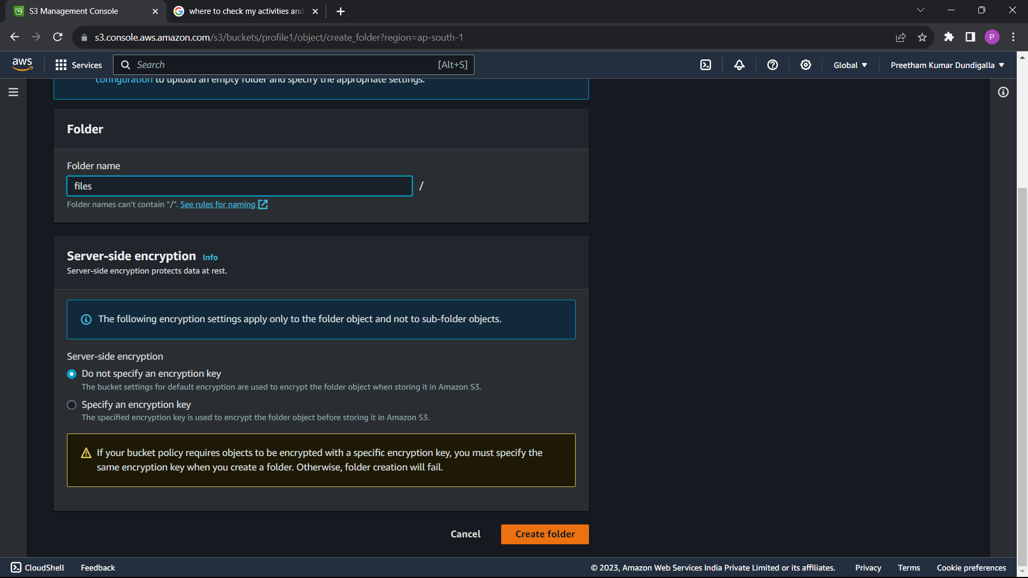

Inside the folder upload the files.

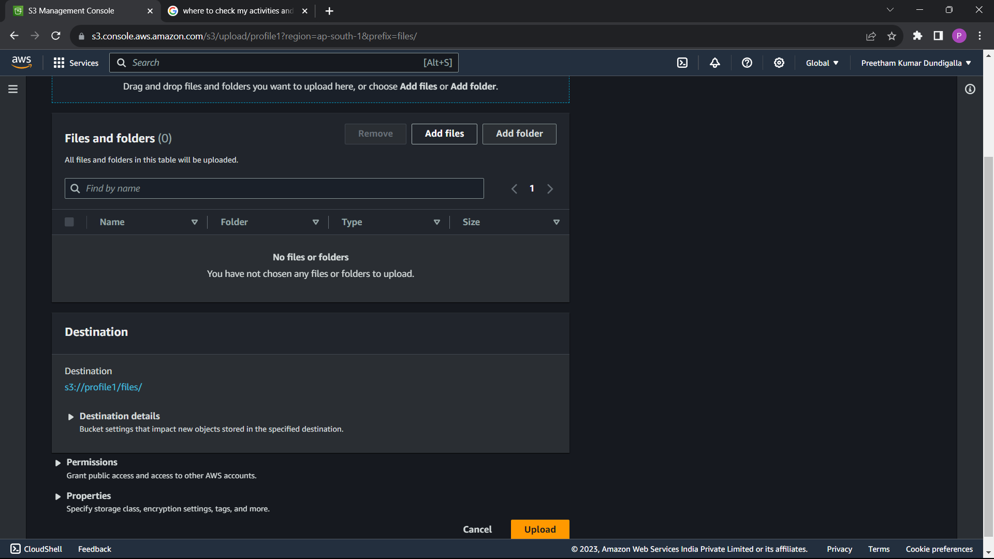

Files are successfully uploaded.

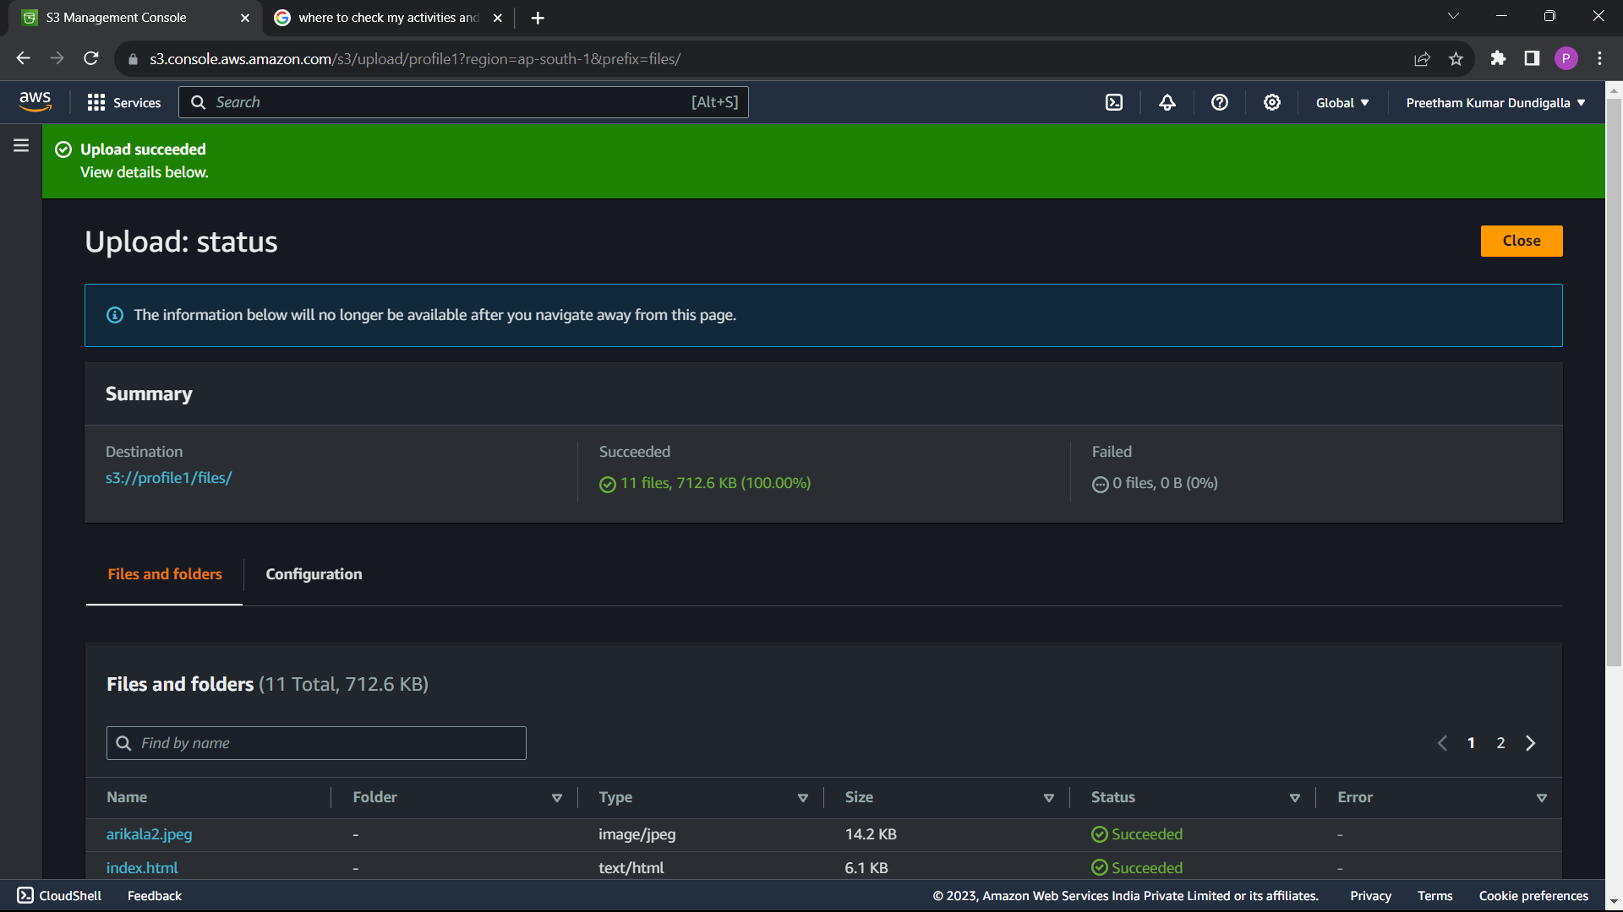

To host the web app, select the bucket, go to properties and enable static website hosting.

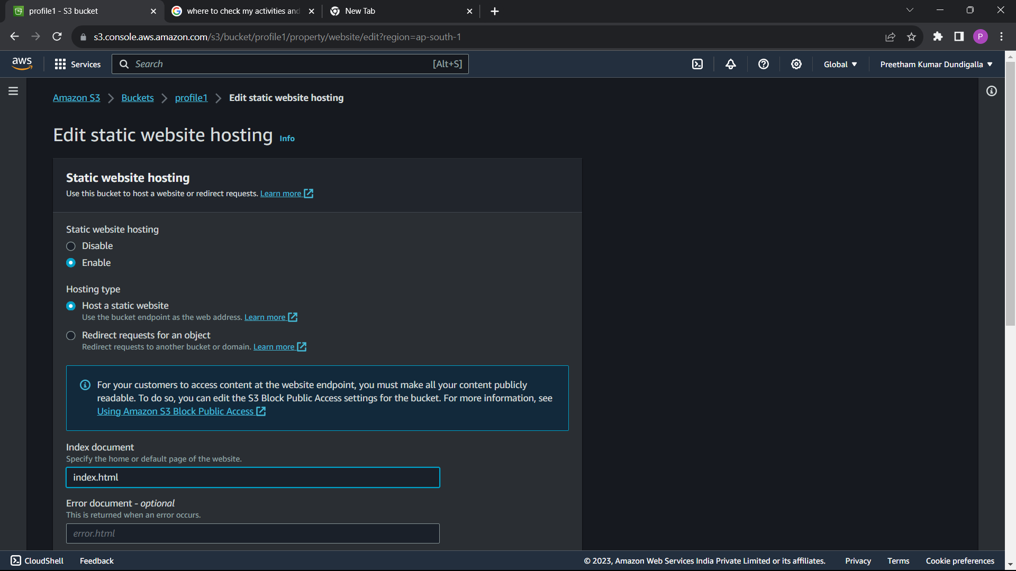

Edit policy in permission, as s3 bucket runs on policies.

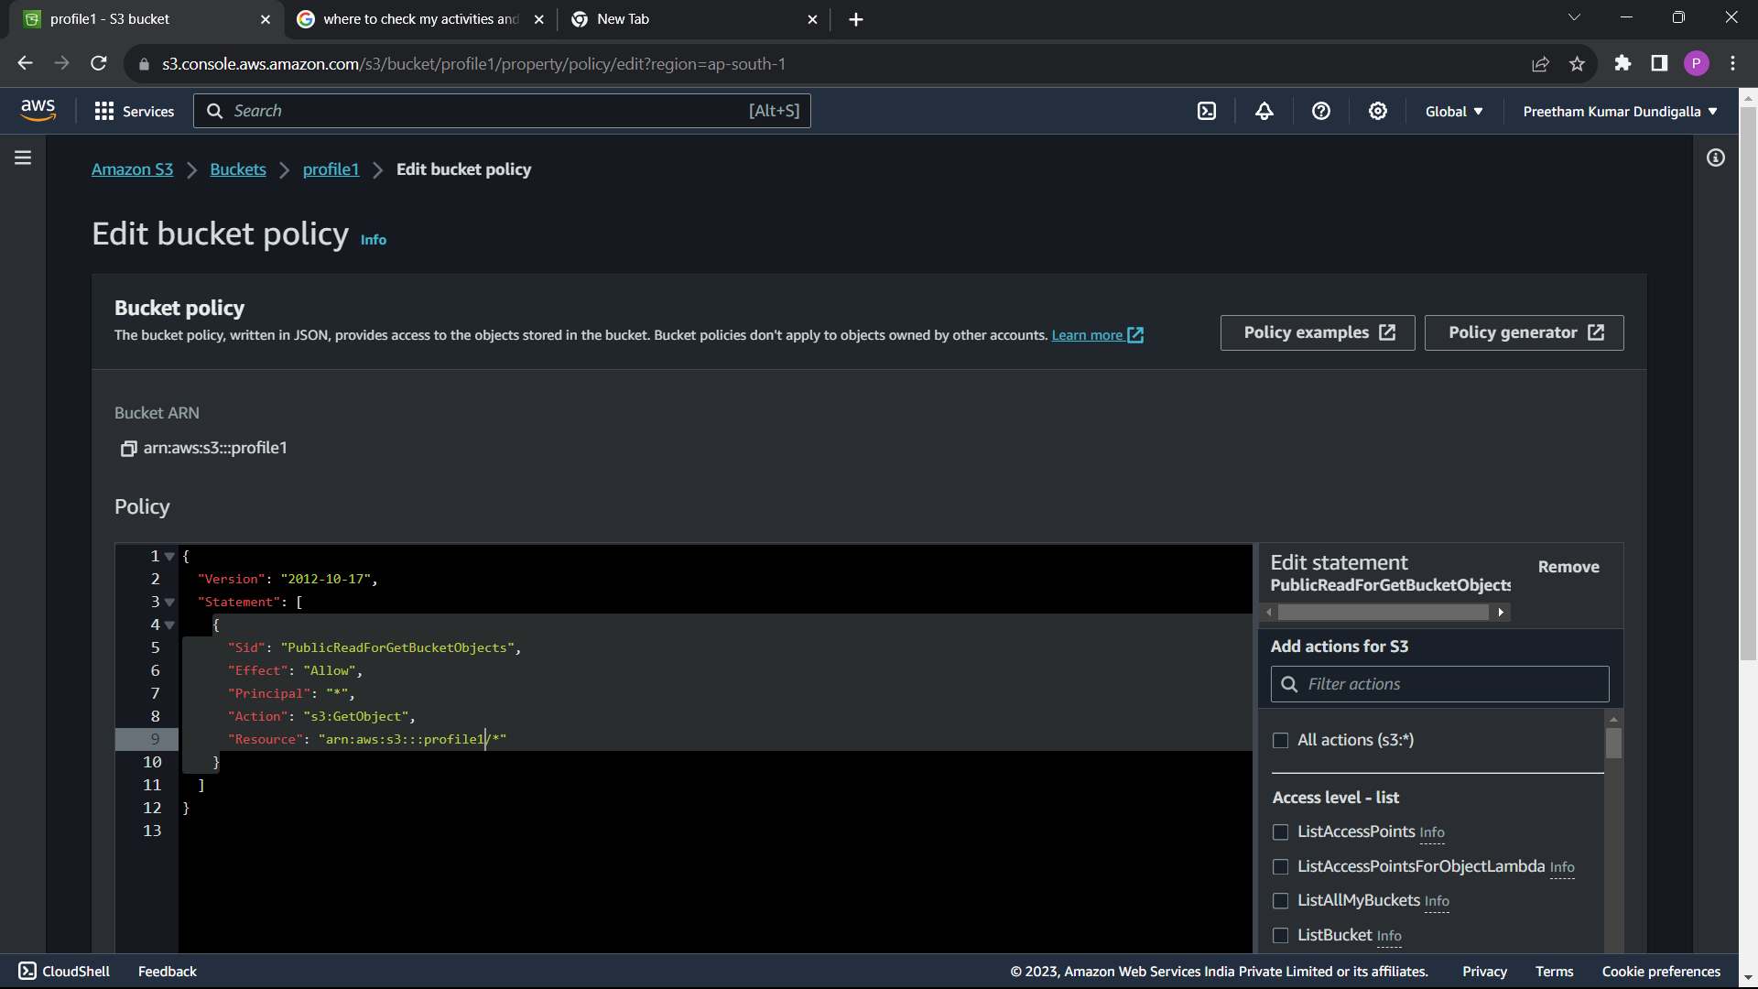

You will get the web app link in static web site under properties

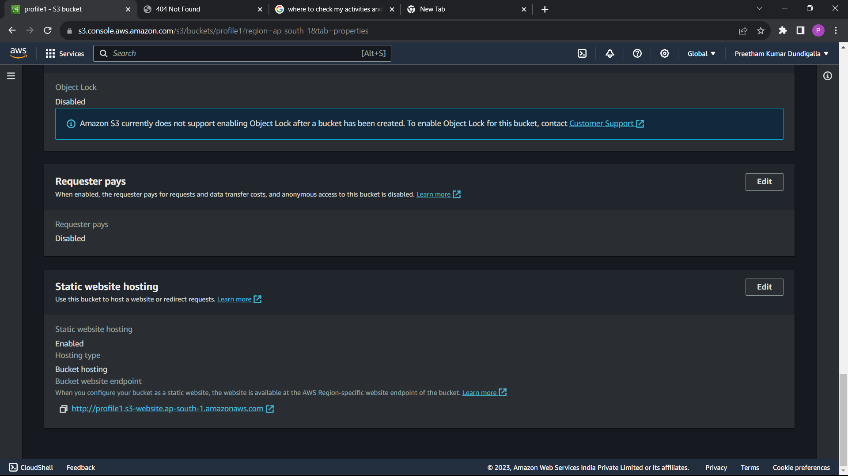

Showing 404 error .

Now I will create a user and give him the access to my buckeet.

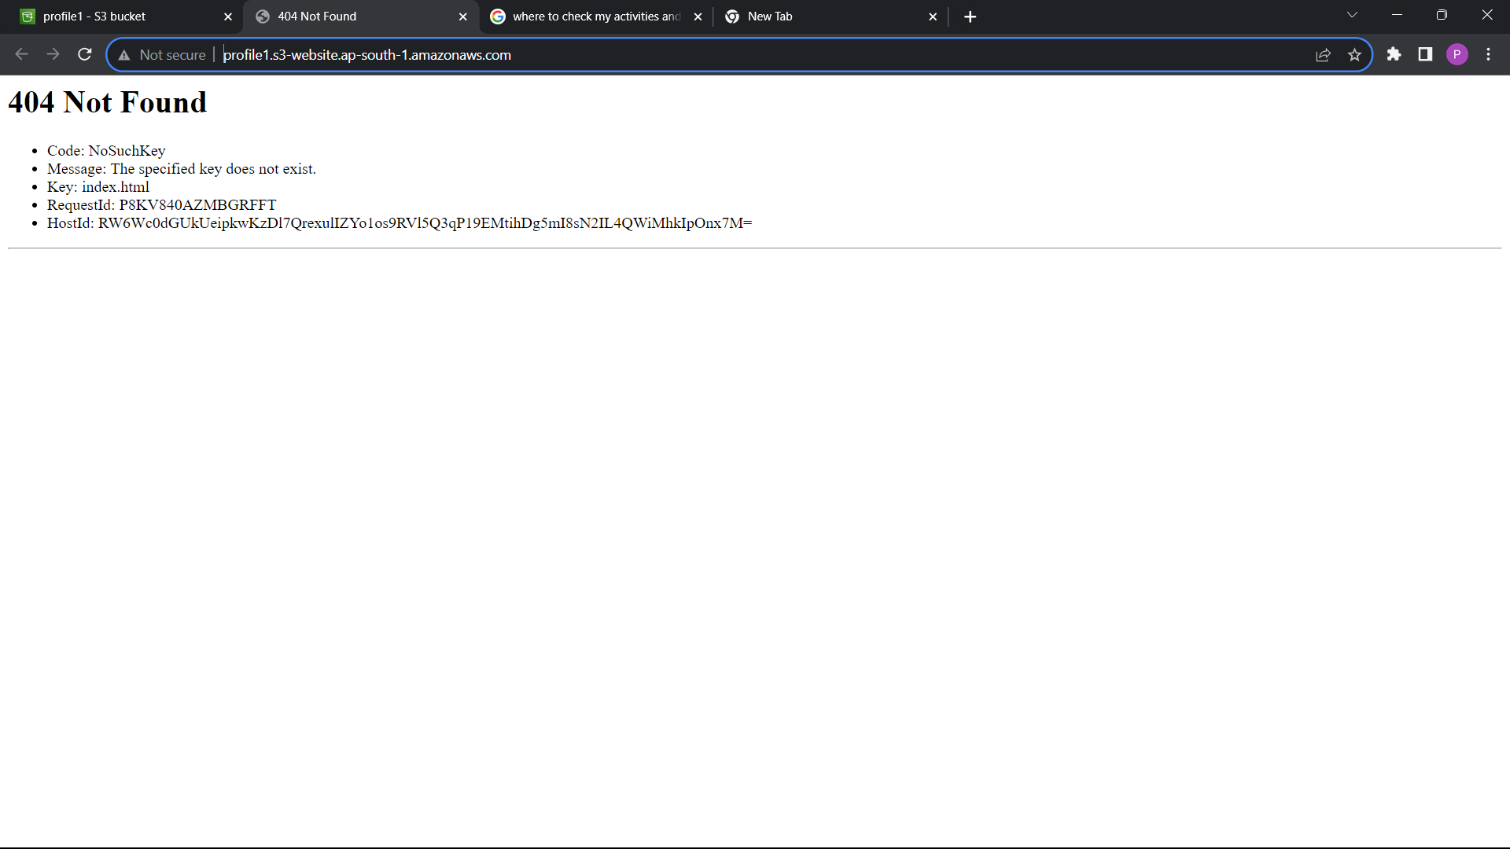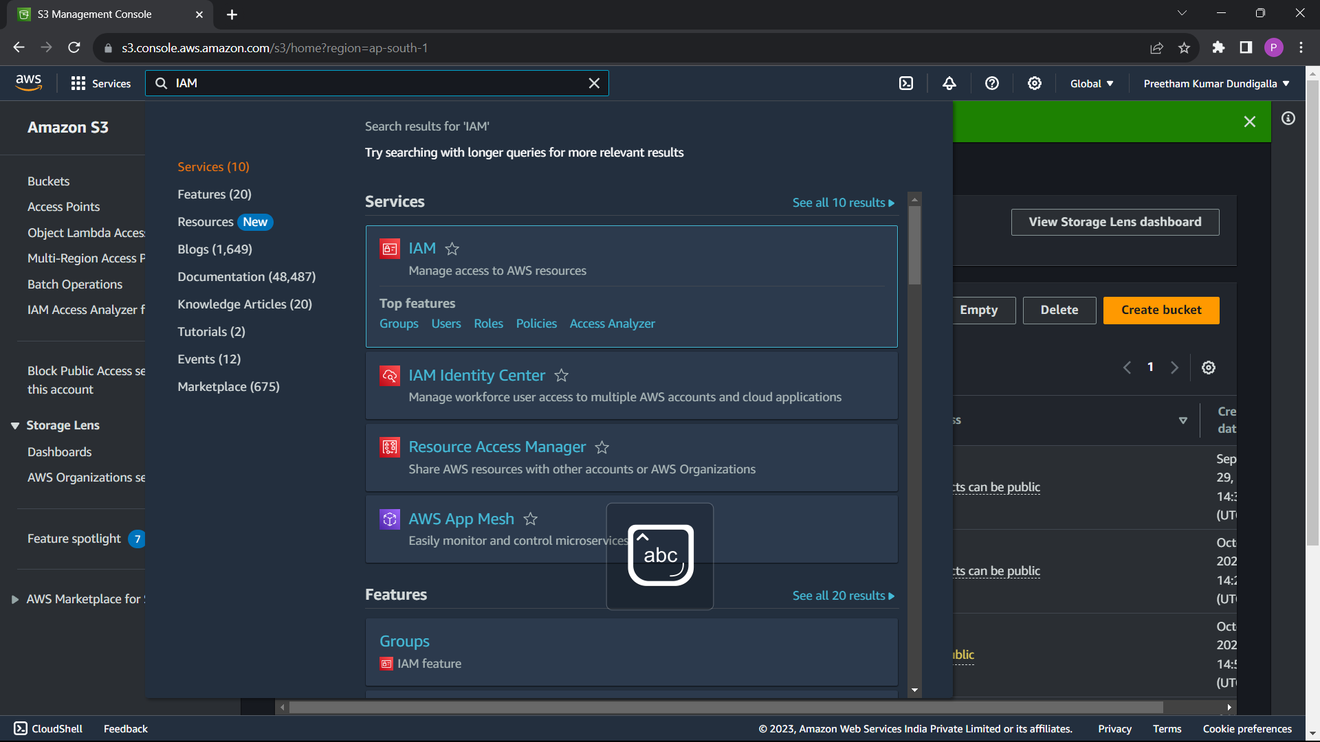

Create user group.

Give name and set policy

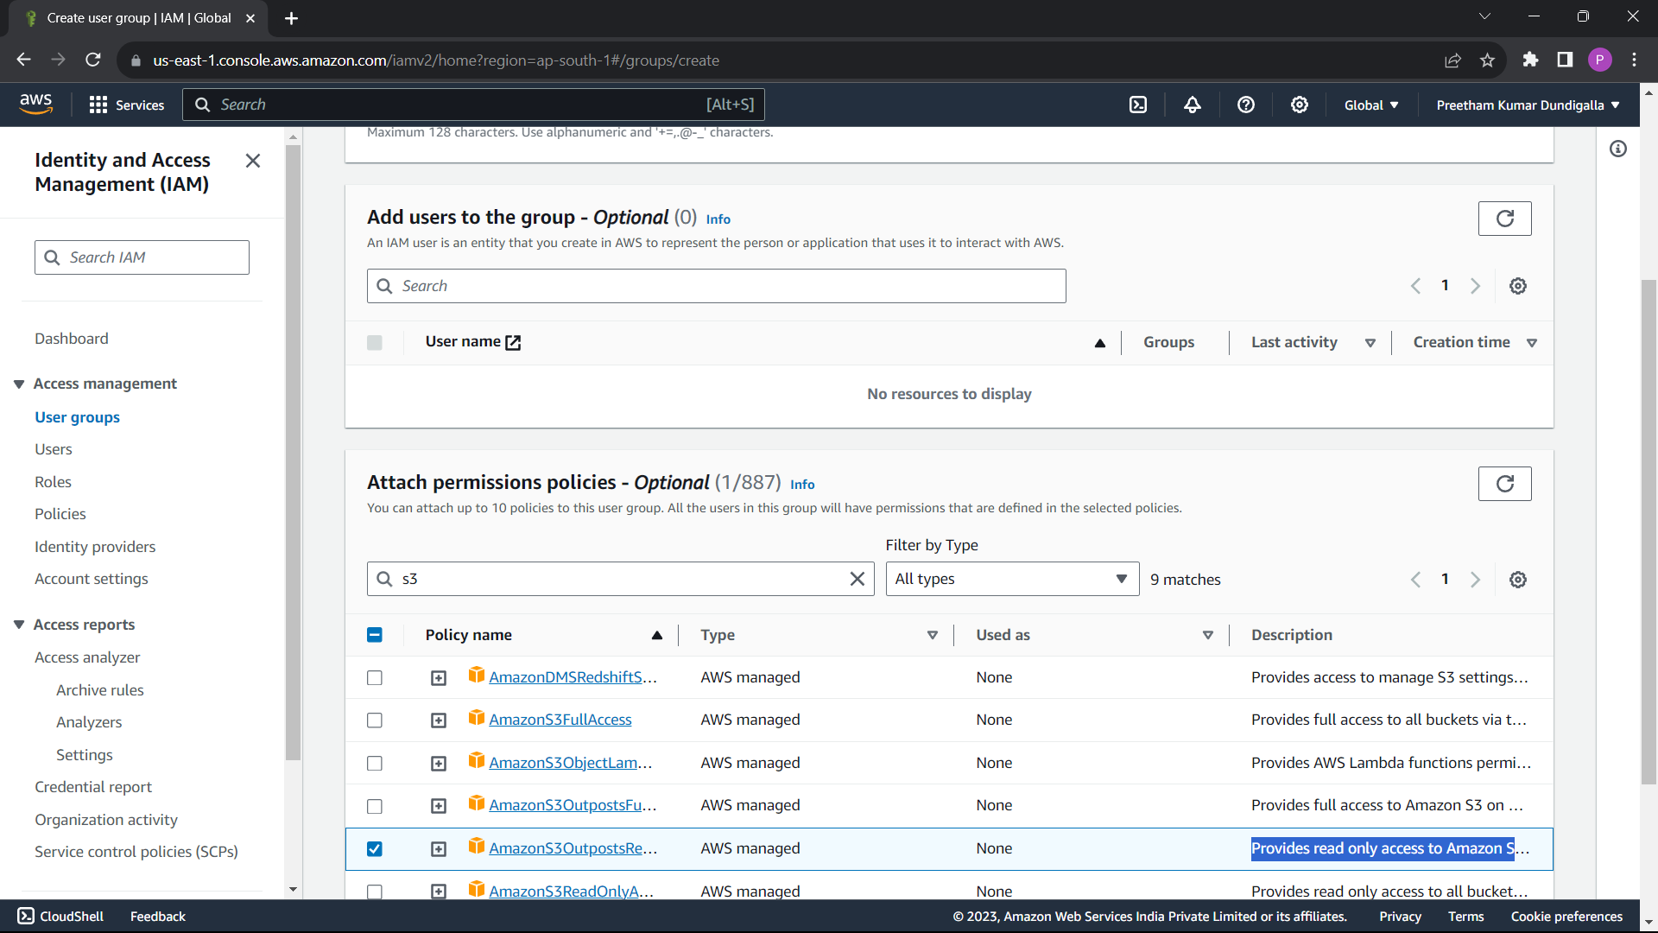

Now create user.

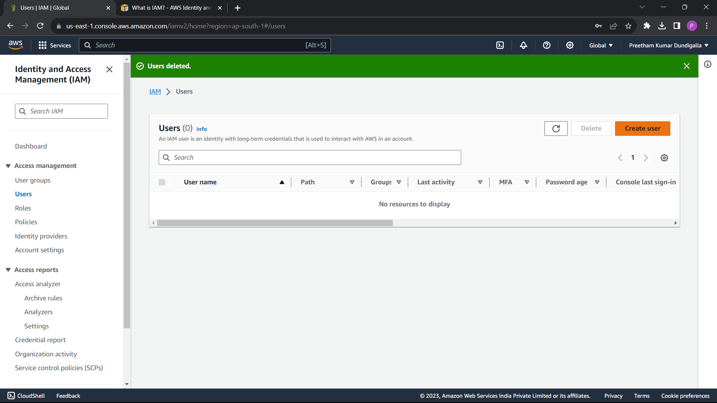

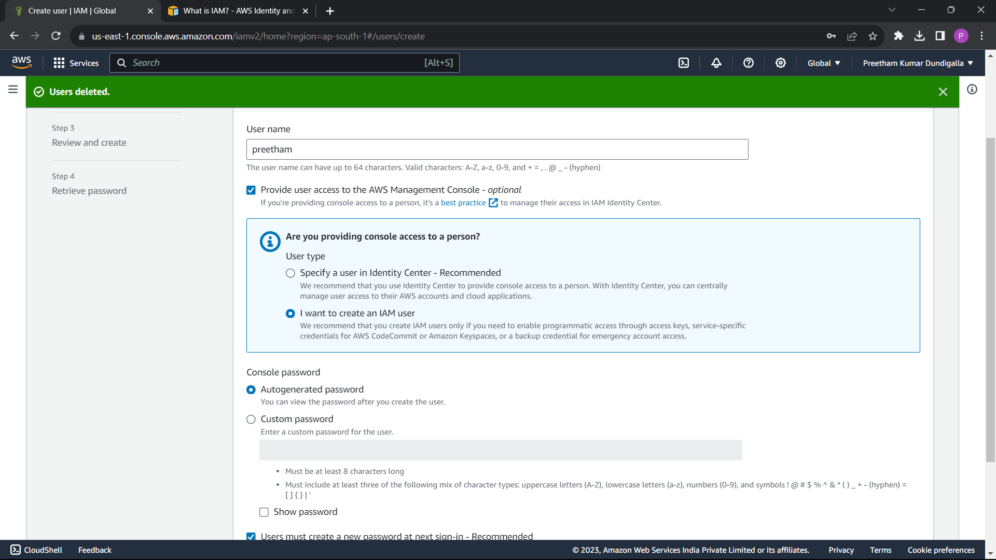

Add user to profile1

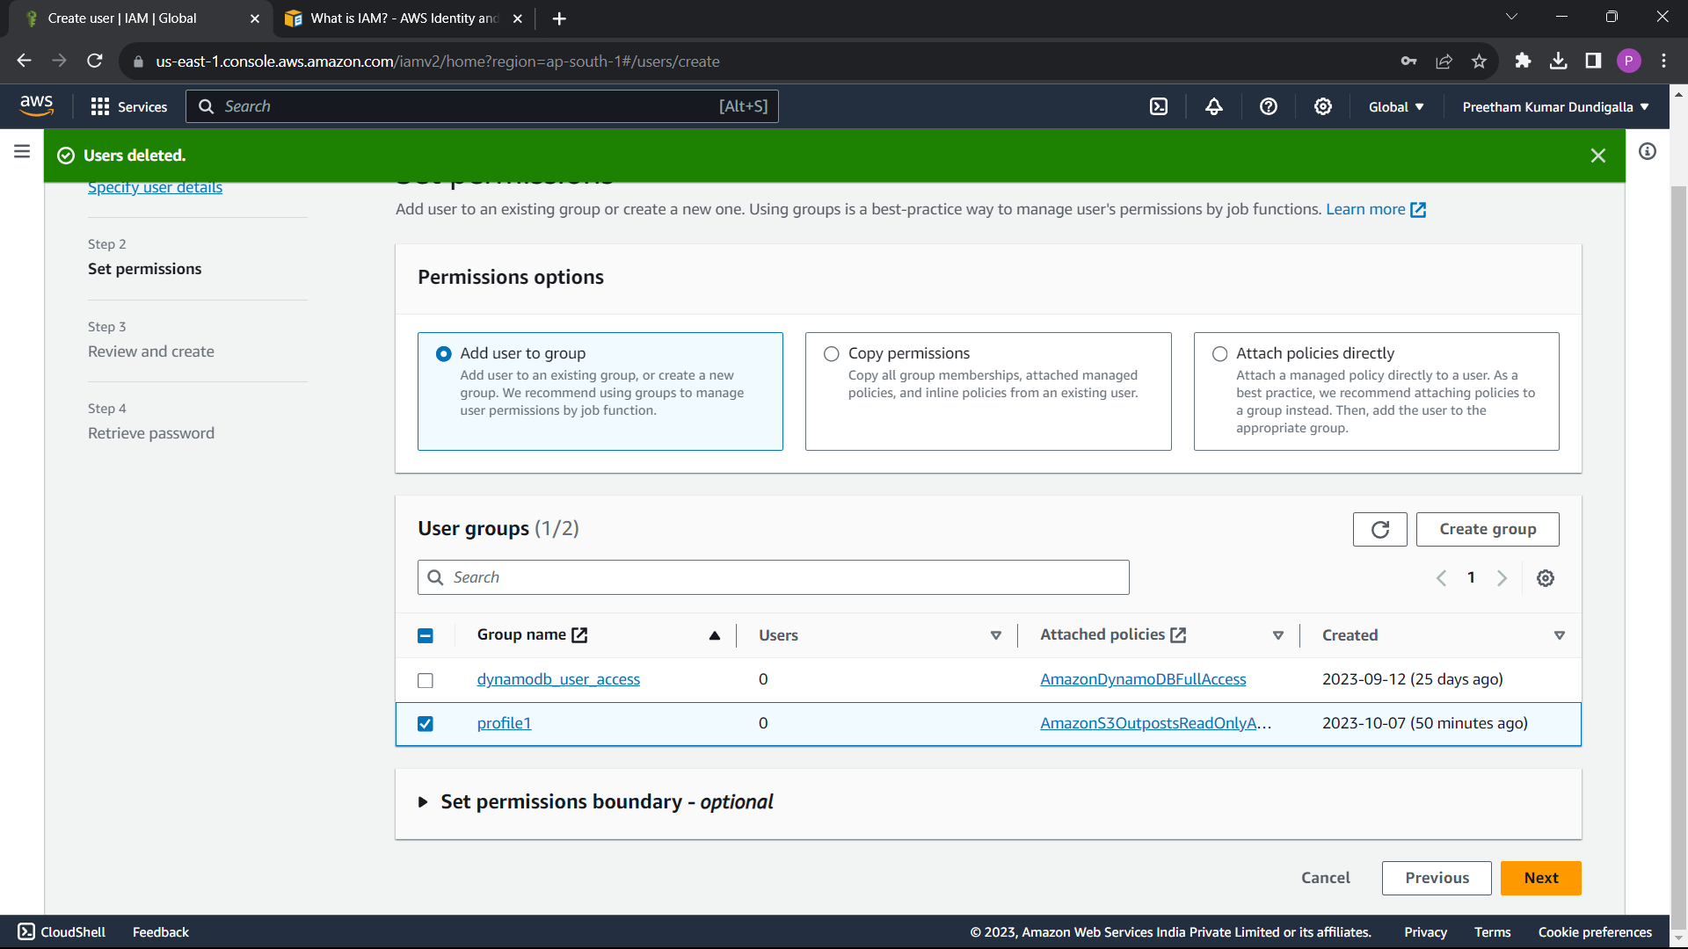

Download the .csv file

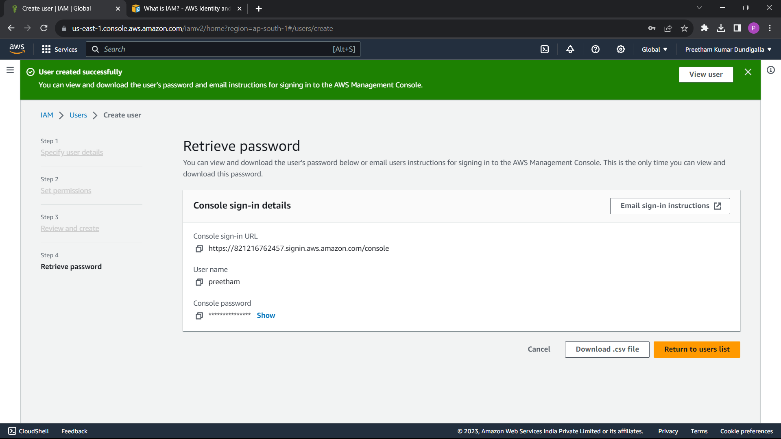

Now user have the permission for s3 bucket.

Click return to user list. Select the user and copy the url link.

Open incognito page and paste the link, username, and password there.

You will see the console like this.

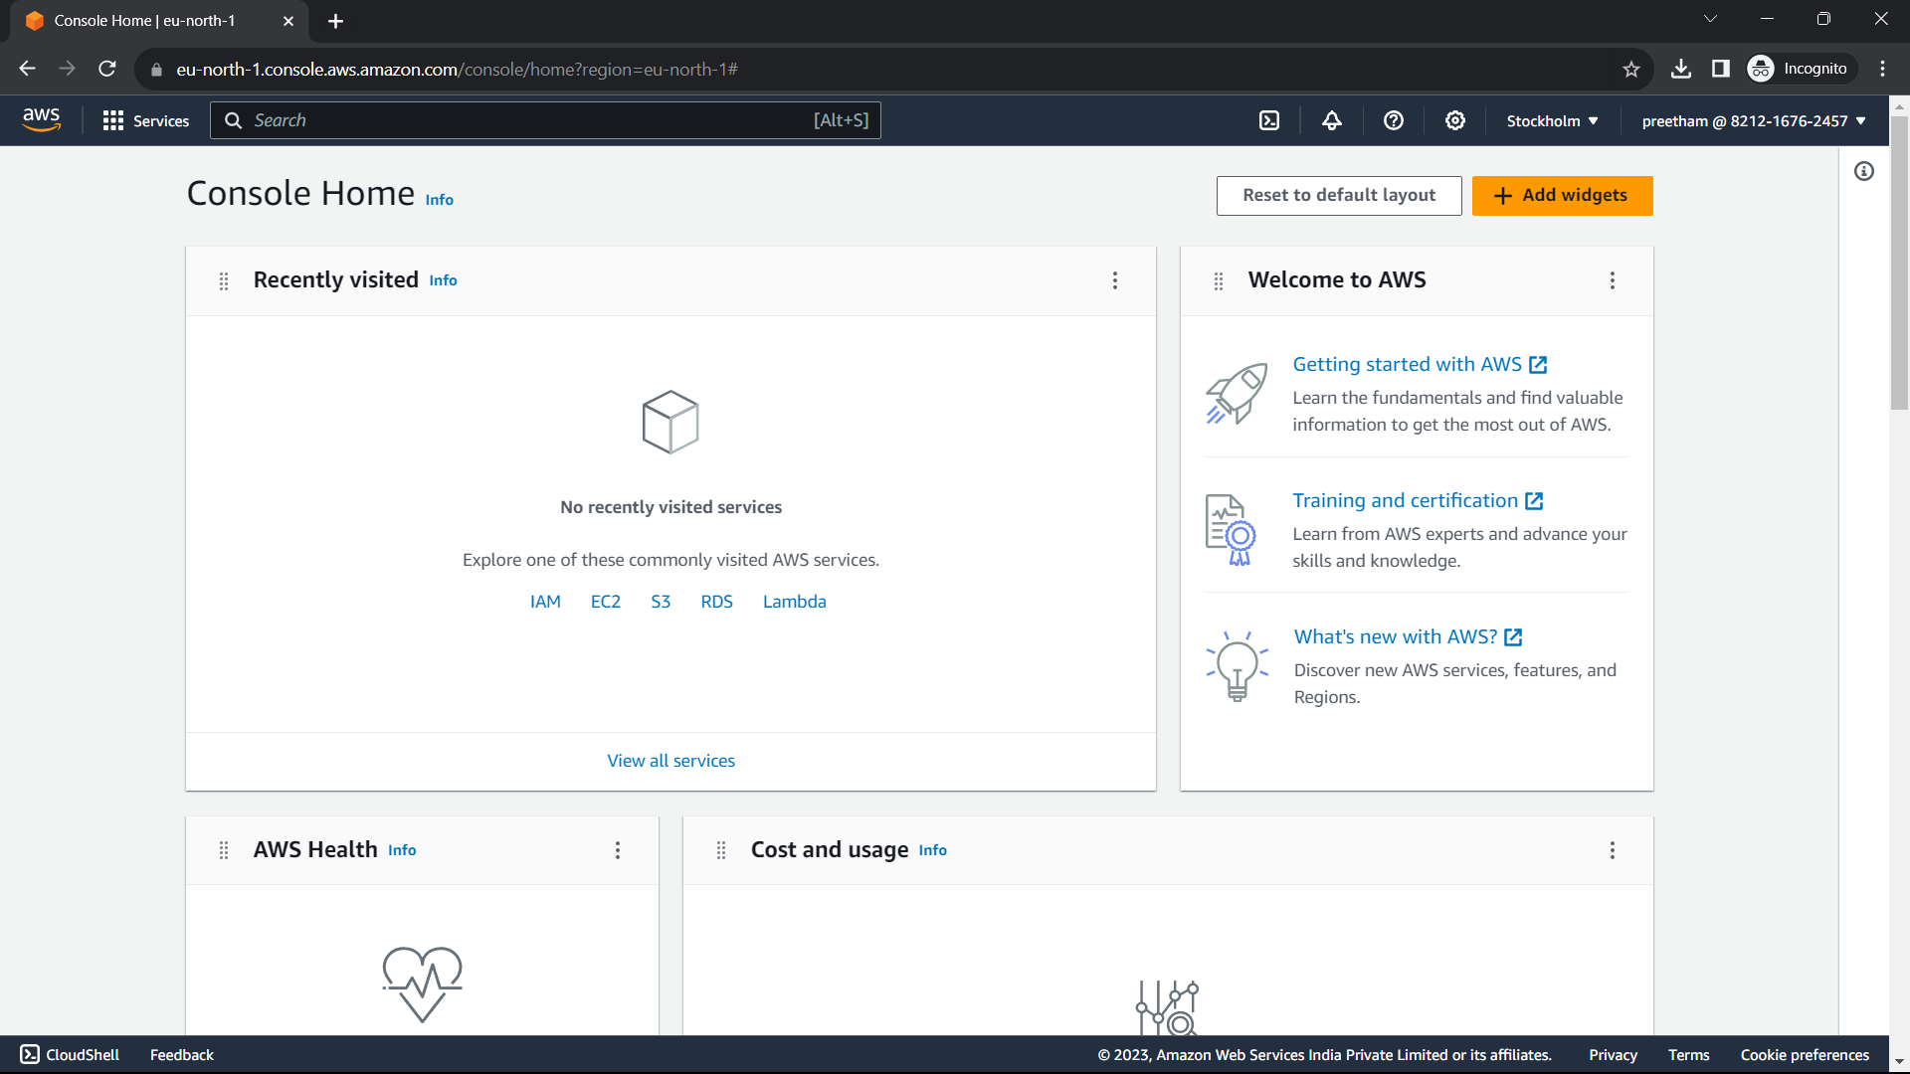

Now you will have access to the s3 bucket. Other than s3 bucket you don’t have permissions to anything.